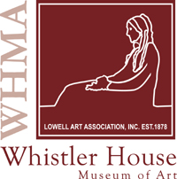Registration Form
Art Quilt Class with Wen Redmond
Saturday June 30, 2018 10 AM – 4 PM

Name: _______________________________________________________________________

Address: ______________________________________________________________________

City, State, Zip: ________________________________________________________________

Phone: _________________________________________________________

E-mail: _________________________________________________________
Class fee is $75.00, and an additional $25 covers a kit including necessary items, for a TOTAL cost of $100. This form and your full payment must be received in order to finalize your registration. The supply list for this quilt and what to bring to class will be available after students register.

Payment Type (circle one): Check Credit Card (please call)

Please make checks payable to “Whistler House Museum of Art”.

