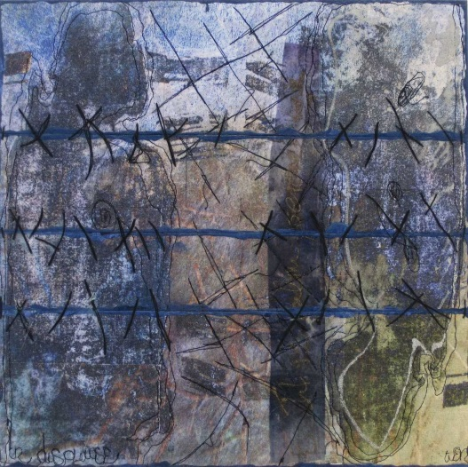

Digital Fiber Mini Quilt
A Quilt Class with Wen Redmond
Saturday June 30, 2018. 10 AM- 4 PM
Join fiber artist Wen Redmond for an all-day quilt class to create your own digital fiber mini quilt! Create a mini 12x12 segmented digital quilt with a new edge treatment that uses paint! Based on Wen’s book, Digital Fiber, create a segmented mini-fabric quilt with a photograph on inkjet ready fiber printed before the workshop! Wen will demonstrate her protective coating and finishing techniques.
The class fee is $75, and an additional fee of $25 covers a kit including a printed fiber image, satin varnish, and specialty mediums. Participants can choose to use a personal photograph! Send the photo in jpeg format one month prior to the class. Photos should be sized to 12x12 or less, in square format, at 180-300 resolution, labeled with your name, and sent to wenredmond@yahoo.com with Digital Fiber Mini Quilt in the subject line.
Student quilts will be exhibited in the Member’s Gallery with Interplay: Fiber and Art Quilts 2018 in the Parker Gallery from August 11 to September 15, 2018.
Space is limited! Please reserve your space by ___________.

Supplies:
14x14 felt for batting
14x14 backing fabric – or just use felt as both
Paper backed fusible webbing for front (and back if you use one)
2” chip brush
1 to 3 colors of inexpensive acrylic paint – include a metallic
Gel medium
Plastic to protect work surface
Sewing machine & supplies
Iron & pad
Hand sewing supplies, pearl cotton, buttonhole thread or similar heavier threads and needle to match the size of chosen thread
Hair dryer
Extension cord or strip
Optional:
Wen’s Book – Digital Fiber Art: Combine Photos & Fabric – Create Your Own Mixed-Media Masterpiece

